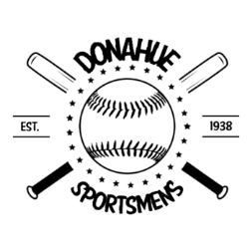DONAHUE SPORTSMENS T-SHIRTS AND SWEATSHIRTS
We are selling t-shirts and hooded sweatshirts with the Donahue Sporstmens Logo on it.
All orders are due April 1st
T-Shirts are $18 ($2 extra for AXXL)
YS (Qty_____) YM (Qty_____) YL (Qty_____)
AS (Qty_____) AM (Qty_____) AXL (Qty_____) AXXL (Qty_____)
Color: Black with white logo Dark Grey with white logo Light Grey with black logo

Sweatshirts are $28 ($2 extra for AXXL)
YS (Qty_____) YM (Qty_____) YL (Qty_____)
AS (Qty_____) AM (Qty_____) AXL (Qty_____) AXXL (Qty_____)
Color: Black with white logo Dark Grey with white logo Light Grey with black logo

Total Amount due __________
Paid Check #__________ Paid Cash__________
***If you would like your kids’ number on the t-shirt or sweatshirt, it will be an extra $2***
***If you would like name on the t-shirt or sweatshirt, it will be an extra $5***

Name_______________________________________________

Phone number________________________________________
Please call Angie Ubel at 563-650-1412 or email at angieubel1979@gmail.com with questions. You can mail orders to
504 W. Valley Drive
Eldridge, IA 52748
Or send order forms with check/cash to John Glenn Elementary School in an envelope with “Attention: Nora Ubel for Angie Ubel” written on the envelope.

